RESSAC
Case study: To provide a process for COTS AEH, ready to apply Overarching Properties (OPs).
Domain: Commercial Off-The-Shelf (COTS) Airborne Electronic Hardware (AEH) or “COTS AEH”.

Context and purpose: An expected target for RESSAC is to assess the Overarching Properties (OPs) and OP’s evaluation criteria (OPCs) based on few representative use cases. COTS AEH are good candidates to quickly test an OP-based assurance approach without the need to refer to the whole set of processes, objectives, activities and data recommended by ED-80/ DO-254 for a developmental AEH.

COTS AEH life-cycle data are anyway not available per ED-80/DO-254, hence an alternative approach must be selected that will necessarily depart from a traditional structured AEH development approach.

The purpose of this use case is to describe more of a product selection approach process including objectives to be met on product artefacts, related activities to be conducted and evidence data to be provided, respectively for a COTS AEH type. Such an approach will then be assessed with respect to the Overarching Properties (OPs) themselves and their OPs evaluation criteria currently established.

Context: In the framework of muXAV EPS system development, resources such as complex or highly complex microcontrollers are anticipated. As it is typically done within industry companies, an upfront activity is performed to be able to select and pre-evaluate COTS AEH candidates that can fit both the product and project needs, together with the envisioned customer and certification requirements.

This present use case describes the process applied to select and collect associated data for a generic COTS AEH solution that could be useful for the muXAV EPS implementation. It starts with a set of information and/or expectations coming from market and potential users. It stops before integration into the upper level hardware item intended for the potentially multiple applications in users’ projects.

Expected benefits
- Establish the activities and artifacts necessary to handle assurance for a COTS AEH,
- Provide a description of a modified and/or new approach to COTS AEH assurance,

Current standards issues:
- Applicable Industry Standard such as ED-80/DO-254 dated April 2000, section 11.2 on COTS, and guidance or Interpretative Material such as EASA Certification Memo (CM) SWCEH-001 Iss. 1 Rev. 1 dated 9th March 2012, chapter 9 on COTS, have been used extensively.

- Difficulties to apply those current Industry standards and Authorities’ certification: None really as EASA CM or equivalent EASA Certification Review Items (CRI) have been used satisfactorily, in complementing ED-80/DO-254 section 11.2 for COTS.

- Compliance demonstration could be based on: Not Applicable. Conformity to both ED-80/DO-254 §11.2 and EASA CM is generally shown and documented via the so-called Electronic Component Management (ECM) process documented in a Plan (ECMP), then in a Report (ECMR).

Process description:

Life cycle overview

The following process consists in six main stages established in grouping COTS AEH-related assurance activities. Note again that for a COTS AEH, no life-cycle process can be really identified as COTS AEH are not developed to DO-254 but procured already developed to COTS supplier’ own company processes, hence without DO-254 compatible life-cycle data.

- COTS AEH Identification of expected needs (Market Surveys, Product Policy constraints, Target Use Cases or Applications)
- COTS AEH Selection and evaluation of the supplier (Data/Documentation identification (datasheet, user’s manual, notes, Complexity Assessment Electronic Component Management Process definition, Capture and assessment of Errata (identification, analysis and workaround)
- COTS AEH Usage Domain Definition, Validation & Verification (forbidden use cases, worst case performance, etc. mitigation of effects of inadvertent activation of unused functions, monitoring of critical configuration settings, etc. Interface Requirements, Constraints (HSI, HHI, etc.)
- COTS AEH Functional Failure Path Analysis (FFPA) or Functional FMEA, particularly for DAL A & B
- COTS AEH Continued configuration management follow up (errata and change analysis, maturity, service history)
- COTS AEH Integration, Validation & Verification, and Qualification to environment: This stage is usually combined with a CBA/LRU-level development process

The first figure below illustrates what are the main processes (Design, Verify and Operate) that are deployed when dealing with incorporation of COTS AEH into a hardware design.
- The Circuit Board Assembly (CBA) design should make sure that the COTS AEH is properly configured and is able to match allocated requirements.
- The verification at CBA level should determine that the COTS AEH, once implemented, will provide the “as required” functions and outputs vs inputs.
- The operation of the COTS AEH is what it is expected to be performed during safe continued service under operating and environmental conditions.

The second figure illustrates how a COTS AEH is generally embedded within some other encompassing electronic hardware item, e.g.: A Circuit Board Assembly (CBA) or product.
The red-circled parts are all those aspect closely associated with the COTS AEH itself. The integration process within an encompassing product can be described in another use case.

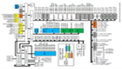
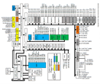
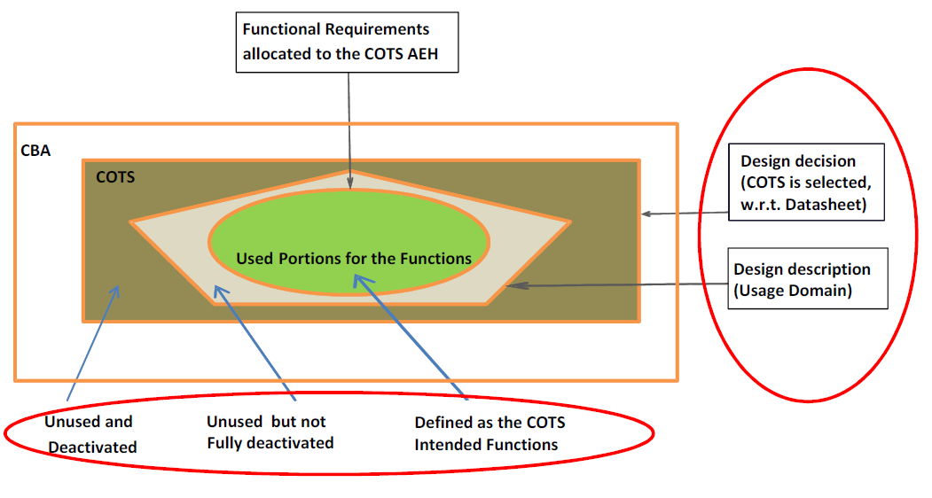
CBA
COTS
I
O
DESIGN
Induction (Intended Output): Designing AEH using the COTS
CBA
COTS
I
O
OPERATE
Deduction (Cause-to-Effect): Operating AEH incl. the COTS
CBA
COTS
I
O
VERIFY
Verification (Expected Output): Verifying AEH with the COTS
Expected Function(s)
OK

The followings address all six stages or sub-processes defined above along with the items of:
- Inputs,
- Outputs,
- Method and environment:
- Responsibility:
- Description:
- Errors sources and classes
- Means to address error sources and classes

- COTS AEH Identification of expected needs and behaviors

Input data:
- Product market data (list of suppliers and segments),
- Components technology data (family of COTS AEH),
- Target applications requirements including criticality (DAL).

Inputs used for process activity:
- Market and technology surveys, both external and internal sources,
- Internal R&T review results, including company Product Policy strategy,
- Target applications feedbacks (usage, functions, safety, constraints, etc.).

Outputs:
- Expected needs and behavior, incl. Safety Reqs & DAL,
- Short list of preselected COTS AEH and their suppliers,
- Key selection factors/criteria for the stage 2 of selection.

Methods & environment: Market Surveys, including competition and specialized publications.

Responsibility:
- R&T experts,
- Marketing experts,
- Quality auditors,
- Product policy manager,
- Technology experts,
- Target applications designers.

Description: The purpose of this activity is to identify the expected needs and behaviors that the COTS AEH will be destined to fulfill and to feature, respectively. This is based on the one hand on application survey to determine which applications are targeted, and on the other hand on state-of-the-art technology survey to determine the candidates COTS AEH and their suppliers. A pre-selection of COTS AEH is made to limit the subsequent activities to satisfy all or part of the needs and behaviors, key selection factors (must have/havn’t) are identified.
1.1 These activities are iterative with reviews involving stakeholders to check if all needs and behaviors are taken into account.
1.2 Reviews to assess the list of candidate COTS AEH with respect to evaluate company maturity in mastering the technology.

Errors sources and classes:

Errors sources | Means of detection
The expected needs or behaviors are not correctly identified (too wide or too narrow or aiming at the wrong target). | 1.1 Reviews at sub-stage 1.1 are there to mitigate the risk
The selected COTS AEH does not fit the expected needs or behaviors or the technology is not mature enough. | 1.2 Review at sub-stage 1.2 and also covered at stage 2.3 & 2.6

- COTS AEH Selection and evaluation of the supplier

Input data (mainly the output from the previous stage 1):
- Expected needs and behavior, incl. Safety Reqs & DAL,
- Short list of preselected COTS AEH and their suppliers,
- Key selection factors/criteria for the stage 2 of selection.

Inputs used for process activity:
- Electronic Component Management Plan (ECMP) guidance and standards,
- COTS AEH detailed data from suppliers, possibly under NDA if necessary,
- Company internal guidance for multi-criteria analyses of complex issues.

Outputs:
- Decision to select only one or a few COTS AEH and Supplier(s) pair(s).
- Selected COTS AEH Data/Documentation from COTS Supplier (datasheet, user’s manual, application notes, errata list, safety data, etc.),
- COTS AEH Electronic Component Management Report (ECMR) including characteristics, performance, evidence of analyses and Audits results.

Methods & environment:
- Reviews and Analyses of COTS AEH suppliers’ data,
- Engineering Assessment vs expected needs & behaviors,
- Audits questionnaires to assess supplier performance.

Responsibility:
Technical experts team supported by other specialties (quality, certification, safety, etc.).
Technical management (Design authority, engineering managers, technical directorate)

Description:
The purpose of this activity is to select only one or a few COTS AEH-Supplier pair(s) able to meet both the expected applications needs and behaviors, and to be acceptable in terms of technology maturity, technical risks and other development and industrial constraints.
The selected COTS AEH-supplier pair(s) should also be shown mastered by designers (e.g. ability to incorporate the COTS AEH within a design via dispositions to control configuration, deterministic behavior and performance).

2.1 Analysis of input data of the preselected list of COTS AEH,
2.2 Narrowing down the list of COTS AEH on the basis of additional data,
2.3 Verification of compatibility versus expected needs and behaviors,
2.4 Check maturity of supplier using privileged information under NDA,
2.5 Selection of only one or a few COTS AEH-Supplier pair(s) from the list,
2.6 Obtain additional feedback from the COTS AEH supplier (under NDA),
2.7 Gathering all resulting data, rationales and references, in the ECMR,
2.8 Peer Review and approval of the ECMR by technical management,
2.9 Archive the whole set of data/documents for subsequent use in the process.

Errors sources and classes:

Errors sources | Means of detection
The COTS AEH selection does not fit the expected needs and behaviors. | Steps 2.1 and 2.3.
The selected COTS AEH is too complex to be adequately mastered. | Step 2.2 may conclude that no additional data is available to continue selection
The COTS AEH technology is too new to be handled properly and safely. | Step 2.5 may result in a conclusion that no COTS AEH can be selected (NoGo).
The COTS AEH has too many residual design errors revealed or not by errata. | Steps 2.4 and 2.6
The COTS AEH datasheet is incorrect or inconsistent with the hardware item. | Step 2.7 may reveal too many defects
The COTS AEH datasheet is incomplete (e.g. undocumented portions). | Step 2.8 may not lead to data approval.

- COTS AEH Usage Domain identification

Input data (mainly output from the previous stage 2 and update from Stage 1):
- Selected COTS AEH Data/Documentation from COTS Supplier (datasheet, user’s manual, application notes, errata list, safety data, etc.),
- COTS AEH Electronic Component Management Report (ECMR) including, characteristics, performance, and analyses and Audits results,
- Optional: Updated expected needs and behavior, incl. Safety Reqs & DAL. At this stage CBA Technical Requirements Specifications (TRS) is available.

Inputs used for process activity: Company guidance on how to build up ECMR, KIT and HSI,

Outputs:
- Updated ECMR, to include identification of the COTS Usage Domain limitations, usable list of functions and prototype evaluation results,
- Hardware – Software Interface (HSI) document for use by Software development (if the COTS AEH is hosting S/W),
- Optional: KIT for proper implementation and usage of The COTS AEH within a hardware CBA application.

Methods & environment:
- Technical analyses (performance, configurability, etc.)
- Peer Reviews of the documented results (ECMR, HSI, KIT),
- Prototype bench (Evaluation board from supplier/vendor),

Responsibility:
- Technical expert team,
- System and Safety experts,
- Designer(s) of the target product(s).

Description: The purpose of this activity is to determine more precisely how the COTS AEH functions can be used (configured, activated/deactivated, passivated, etc.) to meet both the needs and behaviors, and to correctly implement a COTS AEH technically suitable for operation. The results will help complement the ECMR and, if any software is hosted, draft the HSI, and optionally establish an installation KIT for use by the target applications.
A Prototype test bench, i.e. evaluation board procured from vendors or supplier is generally used to go deeper inside the potential usage of the COTS AEH.

3.1 Review of the updated ECMR via peer review of the followins:
- Identification of usable/non-usable functions,
- Analysis of related errata and suggested workarounds,
- Determine appropriate configuration settings,
- Solution for inhibition/monitoring of unused functions,
- Solution for inadvertent loss of critical configuration setting,
- Determine authorized uprating parameters and associated process,

3.2 Review of the KIT provided with the following information:
- How to use or to not use functions via activation, deactivation or passivation,
- A test suite based on prototype evaluation is provided to target applications,
- Application Note with suggested interfaces and implementation constraints.

3.3 Review of the HSI (there is an HSI if the COTS AEH is hosting software)

Errors sources and classes:

Errors sources | Means of detection
ECMR: Activities did not properly identified usable/non-usable functions, known errata, appropriate configuration settings, uprating limits, etc | 3.1 Review of the updated ECMR
KIT uncomplete/erroneous | 3.2 Review of the KIT
HSI uncomplete/erroneous | 3.3 Review of the HSI

- COTS AEH Functional Failure Path Analysis (FFPA)

Input Data (mainly output from the previous stage 3):
- ECMR + HSI + KIT

Inputs used for process activity:
- Procedures, guidance, checklists to conduct FFPA,

Outputs:
- FFMEA/FFPA report at the COTS AEH level for the used configuration,
- Updated ECMR, HSI and KIT

Methods & environment:
- FFMEA/FFPA company guidance and tools

Responsibility:
- FFMEA/FFPA Expert

Description: The purpose of this activity is to assess the dysfunctional behavior of the COTS AEH on the basis of a first level of functional block diagram and the associated failure conditions using both failure data from the COTS AEH supplier (both qualitative and quantitative). This assessment is of particular importance for COTS AEH embedded within CBA design to DAL A and B.

4.1 The FFMEA/FFPA is done qualitatively, then quantitatively if failure rate data is available.
- Dysfunctional analysis at functional block level within the COTS AEH,
- Assessment and mitigation of relevant errata and their impact on safety,
- Identification of critical failures situations: errors in configuration settings.

4.2 Based on results, complement available data with the COTS AEH supplier (e.g. information on actual architecture, suggested protection or monitoring mechanisms, quantitative figures)

4.3 Use the FMEA/FFPA results to provide safety recommendations in the KIT

4.4 Final review of the FFMEA/FFPA report and review of the updated KIT

Errors sources and classes:

Errors sources | Means of detection
Incomplete FFMEA/FFPA analysis | 4.4 Peer Review of the FFMEA/FFPA results

- COTS AEH Continued Airworthiness

This activity is out of the scope of a product or system development.
However, in the frame of a process oriented assurance demonstration, it could be of interest to provide a process that guarantee the sustainability and the reproducibility of COTS usage during all the service life of the product (e.g. new errata are assessed not only during design, but are continuously assessed, together with Change Impact Analysis (CIA) based on Product Change Notices (PCN) and potential impact on safety. A Failure Reporting, Analysis and Corrective Action (FRACAS) system is deployed and cumulated Product Service Experience (PSE) may be recorded for future use.

This stage should also incorporate miscellaneous activities related to the COTS AEH, e.g. configuration management, process assurance, certification liaison.

- COTS AEH Integration and verification

Performed as part of CBA/LRU (product) design, development and integration processes for a specific application. Generic ECMR (including usage domain recommendations), available documentation and additional data from COTS AEH Supplier are considered as inputs for the end-user projects that decide to implement this suggested COTS AEH as a solution to its system requirements.

This stage should also incorporate miscellaneous activities related to the COTS AEH:
- Verification of COTS Usage Domain vs allocated requirements,
- Verification of technical suitability in general (e.g. performance, robustness),
- Verification of H/W-H/W and H/W-S/W Interfaces (if any),
- Functional Verification of the LRU including the COTS (at LRU level),
- Environmental Qualification of the LRU including the COTS (LRU level),
- Acceptance Verification (at LRU level, particularly for safety mechanisms).

Artefacts examples:

Miscellaneous artifacts are used when applying OPs. For a COTS AEH such artifacts are produced as a result of adequate activities. An example of Electronic Component Management Report (ECMR) is provided.



